ARTICLE READING PRACTICE
Directions: Read the articles about discovery, and then complete the questions below.

Article 1:
Steady Hands and Fins
Photograph by Jennifer Hayes, National Geographic
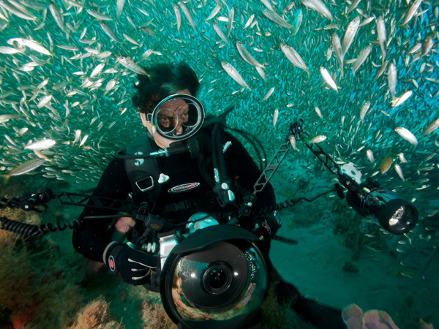
Exploring the world's waters, National Geographic photographer David Doubilet has photographed in the depths of such places as the southwest Pacific, New Zealand, Canada, Japan, Tasmania, Scotland, and the northwest Atlantic. Here, he explores a shipwreck that has been turned into an artificial reef. His work has taken him to freshwater ecosystems such as Botswana's Okavango Delta and Canada's St. Lawrence River. He has photographed stingrays, sponges, and sleeping sharks in the Caribbean as well as shipwrecks in the South Pacific, the Atlantic, and at Pearl Harbor.
“What separates humans from other animals is not just an opposable thumb, not just our ability to create electric trains or build buildings; we have this extraordinary appreciation of beauty. Given the right moments, we also have an extraordinary ability to destroy things. There are a million scientific reasons why we should save a tiger, or a tiger shark, and they are real reasons. But ultimately, the bottom-line reason is because it is beautiful.
"The ocean is beautiful. A coral reef may arguably be the most beautiful environment on the face of the planet. It's a place that's flooded with light, yet has the most intense colors of any other environment on the planet. We can't destroy this; we have to hold onto this thing and pay attention. “
Complete the Quick Outline Below according to the information in the article:
Who: _ _ _ _ _ _ _ _ _ _ _ _ _ _ _ _ _ _ _ _ _ _ _ _ _ __ _ _ _ _ _ _ _ _ _ _ _ _ _ _ _ _ _ _ _ _ _ _ _ _ _ _ _ _ _ _ _ _ _ _ _ _ _
What: _ _ _ _ _ _ _ _ _ _ _ _ _ _ _ _ _ _ _ _ _ _ _ _ __ _ _ _ _ _ _ _ _ _ _ _ _ _ _ _ _ _ _ _ _ _ _ _ _ _ _ _ _ _ _ _ _ _ _ _ _
When: _ _ _ _ _ _ _ _ _ _ _ _ _ _ _ _ _ _ _ _ _ _ _ _ __ _ _ _ _ _ _ _ _ _ _ _ _ _ _ _ _ _ _ _ _ _ _ _ _ _ _ _ _ _ _ _ _ _ _ _ _
Where: _ _ _ _ _ _ _ _ _ _ _ _ _ _ _ _ _ _ _ _ _ _ _ _ __ _ _ _ _ _ _ _ _ _ _ _ _ _ _ _ _ _ _ _ _ _ _ _ _ _ _ _ _ _ _ _ _ _ _ _ _
Why: _ _ _ _ _ _ _ _ _ _ _ _ _ _ _ _ _ _ _ _ _ _ _ _ _ __ _ _ _ _ _ _ _ _ _ _ _ _ _ _ _ _ _ _ _ _ _ _ _ _ _ _ _ _ _ _ _ _ _ _ _ _
How: _ _ _ _ _ _ _ _ _ _ _ _ _ _ _ _ _ _ _ _ _ _ _ _ _ __ _ _ _ _ _ _ _ _ _ _ _ _ _ _ _ _ _ _ _ _ _ _ _ _ _ _ _ _ _ _ _ _ _ _ _ _
T.S. (Summary): _____________________________________________________________________________________
____________________________________________________________________________________________________________________________________________________________________________________________________

ARTICLE 2:
Pebble Toad
Photograph by Joe Riis
Deep in the remote Wokomung Massif in the Pacaraima Mountains of Guyana, photographer Joe Riis joined herpetologist Bruce Means on a 2012 expedition to study pebble toads and look for new frog species.
"This is a female pebble toad or Oreophrynella macconnelli. It's the only arboreal toad in the world that climbs trees, with handlike front and back feet.
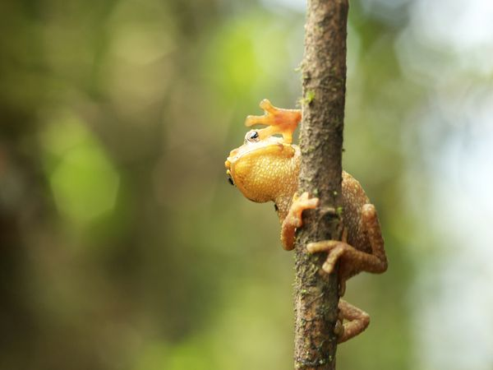
"The tiny pebble toad was climbing up toward me, like they often did during this expedition. However, this time was different; it stopped and turned to look back down the branch. Meanwhile I was able to make one picture, which looks likes it's waving to the viewer. I love this picture; it brings a smile to my face and my mind back to this expedition every time I see it!"

Complete the Quick Outline Below according to the information in the article:
Who: _ _ _ _ _ _ _ _ _ _ _ _ _ _ _ _ _ _ _ _ _ _ _ _ _ __ _ _ _ _ _ _ _ _ _ _ _ _ _ _ _ _ _ _ _ _ _ _ _ _ _ _ _ _ _ _ _ _ _ _ _ _ _
What: _ _ _ _ _ _ _ _ _ _ _ _ _ _ _ _ _ _ _ _ _ _ _ _ __ _ _ _ _ _ _ _ _ _ _ _ _ _ _ _ _ _ _ _ _ _ _ _ _ _ _ _ _ _ _ _ _ _ _ _ _
When: _ _ _ _ _ _ _ _ _ _ _ _ _ _ _ _ _ _ _ _ _ _ _ _ __ _ _ _ _ _ _ _ _ _ _ _ _ _ _ _ _ _ _ _ _ _ _ _ _ _ _ _ _ _ _ _ _ _ _ _ _
Where: _ _ _ _ _ _ _ _ _ _ _ _ _ _ _ _ _ _ _ _ _ _ _ _ __ _ _ _ _ _ _ _ _ _ _ _ _ _ _ _ _ _ _ _ _ _ _ _ _ _ _ _ _ _ _ _ _ _ _ _ _
Why: _ _ _ _ _ _ _ _ _ _ _ _ _ _ _ _ _ _ _ _ _ _ _ _ _ __ _ _ _ _ _ _ _ _ _ _ _ _ _ _ _ _ _ _ _ _ _ _ _ _ _ _ _ _ _ _ _ _ _ _ _ _
How: _ _ _ _ _ _ _ _ _ _ _ _ _ _ _ _ _ _ _ _ _ _ _ _ _ __ _ _ _ _ _ _ _ _ _ _ _ _ _ _ _ _ _ _ _ _ _ _ _ _ _ _ _ _ _ _ _ _ _ _ _ _

T.S. (Summary): _____________________________________________________________________________________
____________________________________________________________________________________________________________________________________________________________________________________________________

Critical Thinking Questions
Drive to Discover, Article 1, Steady Hands and Fins

According to Doubliet, what separates humans from other animals?
______________________________________________________________________________________________________________________________________________________________________________________________________

How does David Doubilet feel about nature?
____________________________________________________________________________________________________________________________________________________________________________________

Drive to Discover, Article 2, “Pebble Toad”
What did this person or people discover or explore? Why was this discovery important?
______________________________________________________________________________________________________________________________________________________________________________________________________________________________________________________________________________________________________________________________________________________________________________________________________

