“Mongolia Read Aloud”
School 23 & the U.S. Embassy Celebrate World Read Aloud Day!
Before we read…
One thing I am grateful for today… ________________________________________________________________________________________________________________________________________________________________________________________________________

“Give A Little Bit” sung by the Goo Goo Dolls
1. _______________________ 2. _______________________ 3. _______________________
4. _______________________ 5. _______________________ 6. _______________________
7. _______________________ 8. _______________________ 9. _______________________

What have you given lately?
________________________________________________________________________________________________________________________________________________________________________________________________________

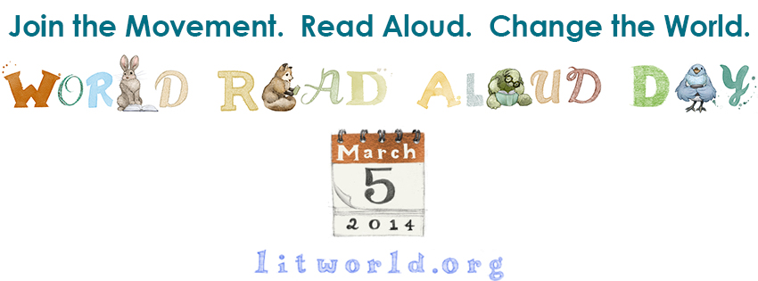
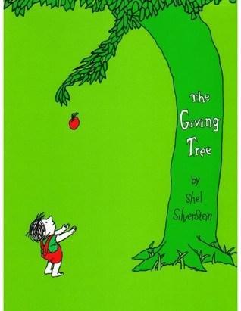
The Giving Tree by Shel Silverstein
As you read the story, think about…
- Try to picture the little boy and how he is with the tree
- What is the boy and the tree’s relationship like?
- What does it mean to love someone? What do we do for the people we love?

After we read…
Choose 2 of the following questions to think about and answer:
- Who is selfless, the tree or the boy? Who was happy in the book, the tree or the boy? Why?
- Can you relate this book at all to your own life? Or to the real world?
- Why did the author write the book?
- Do you think you can ever give too much? Why or why not?
Answers:
_______________________________________________________________________________________________________________________________________________________________________________________________________________________________________________________________________________________________________________________________________________________________________________________________________________________

